*Important information*

Top Tips!

My-School and Google Classroom

- Please continue to refer to the help guides on the website for step by step guidance.
(Parents’ Area, Google Classroom Support) https://www.cookstownps.co.uk/

- Always sign in using the My-School, C2k username and password provided.

- Select the Google Classroom app and then use the Google Classroom username to log in. Please remember to use your child's C2k password as the Google Classroom password.

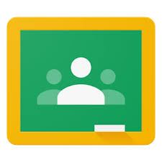
- After successfully logging in, please select the + symbol to join the class and use the Google Classroom code provided. This step is detailed in the help guide.

