Google Classroom - Hahú
- Klik ligasaun ida-ne’e: https://classroom.google.com/
ka ketik enderesu URL ida-ne’e iha bara enderesu URL nian iha navegadór internét

- Hahú (log-on) hodi uza Ita rasik nia informasaun C2k nian:
- Hatama Ita-nia enderesu email (letra primeiru ba Ita-nia naran, apelidu, númeru hamutuk tolu):
Porezemplu: cmcpeake001@c2ken.net
- Liafuan xave mak hanesan ho liafuan xave ne’ebé Ita uza atu hahú (log-on) bainhira Ita sei iha eskola.
- Klik ‘Next’
- Bainhira ‘screen azul’ mosu, hatama Ita-nia email C2k nian dala ida tan, porezemplu:
- cmcpeake001@c2ken.net
- Liafuan xave mak hanesan ho liafuan xave ne’ebé Ita uza atu hahú (log-on) bainhira Ita sei iha eskola.
- Klik ‘Sign in’

Google Classroom – Liga ho klase ida hodi uza Ita-nia ‘Class Code’
- Klik iha ‘+’
- Klik ‘Join Class’

- Hakerek Ita-nia ‘Class Code’ (kódigu klase nian) iha screen tuirmai.
- Ita-nia klase sei mosu, Klik iha naran ne’ebé loos (porezemplu Year 11 ICT) atu bele haree Ita rasik nia serbisu eskola nian.

Google Classroom - Liga ho klase kuandu la iha ‘Class Code’ ida
- Klik ligasaun ida-ne’e: http://www.c2kschools.net
ka ketik enderesu URL ida-ne’e iha bara enderesu URL nian iha navegadór internét
- Ketik Ita-nia naran utilizadór C2k nian (porezemplu cmcpeake001) no liafuan xave. Tuirmai klik butaun Login (Hahú) nian
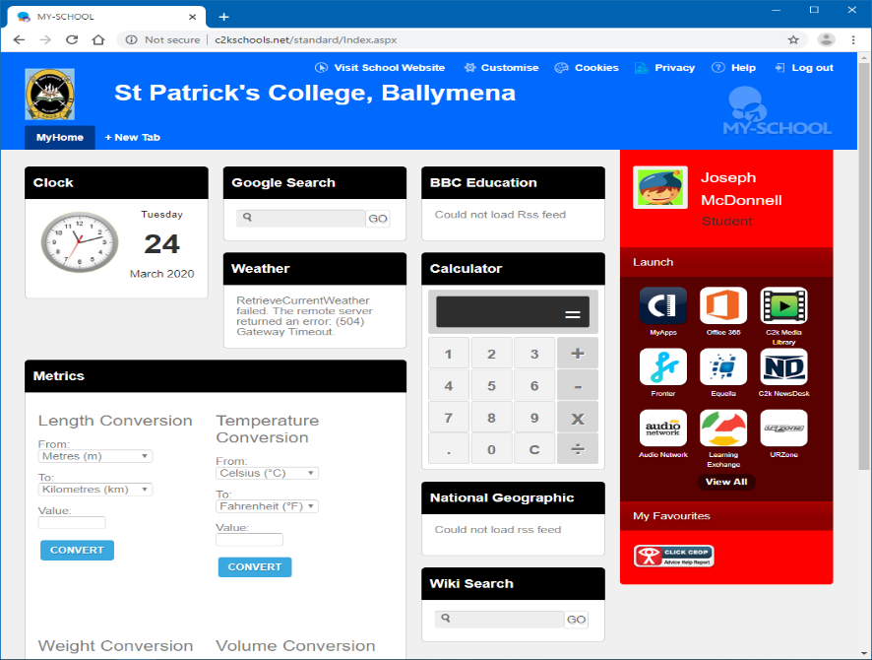
Paddy
Mena

- Ita-nia MySchool home page sei mosu hanesan dezeñu ida-ne’e.
- Ita bele loke Google Classroom hodi klik iha View All

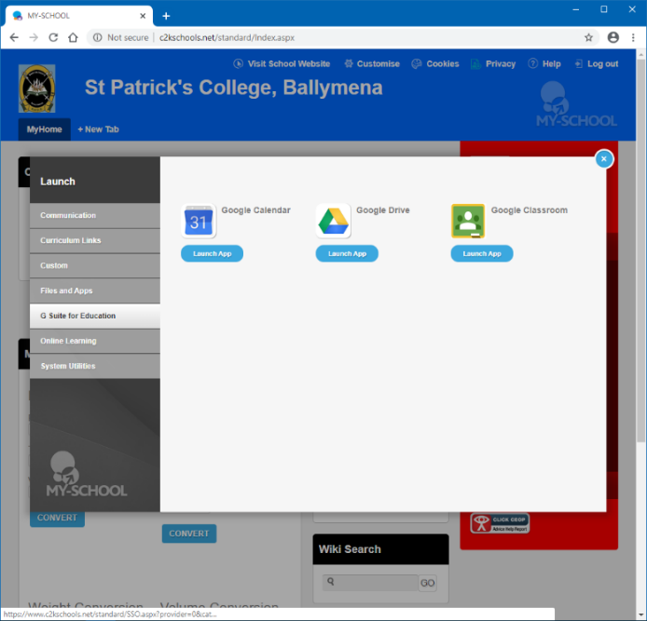
- Klik iha ligasaun G Suite for Education
- Tuirmai, klik iha butaun Google Classroom Launch App nian
- Kontinua hodi tuir matadalan iha Pájina 1.
- Agora Ita tama ona iha Ita-nia Google Classroom.
- Se karik, Ita nafatin la bele loke Google Classroom loke Ita-nia eskola nia email no buka ba Class Code (Kódigu Klase) husi Ita-nia mestre/a. Haree matadalan iha Pájina 3

